Gail B. Goodman
If you’ve heard of “The PhoneTeacher,” you know Gail Goodman.
For three decades Gail has trained over 90,000 financial professionals. Her career has been devoted to helping advisors to schedule that critical, initial face-to-face appointment. Her recent books Modern Appointment Setting and Setting Appointments in the Smartphone World address the most up to date ideas on creating new clients through setting initial appointments.
Gail has continually updated her training and materials to reflect our ever-changing environment. Even though smartphones are integral to our everyday life, nothing replaces the sound of the human voice. It is important to synthesize technology, phone calls and face-to-face opportunities in your marketing.
Gail’s training includes on-site seminars, webinars and Zoom role playing to help advisors and managers improve their scripts, coaching sessions and individual advisor supervision.
Gail lives on a horse farm outside of Nashville with her husband and too many animals.

rga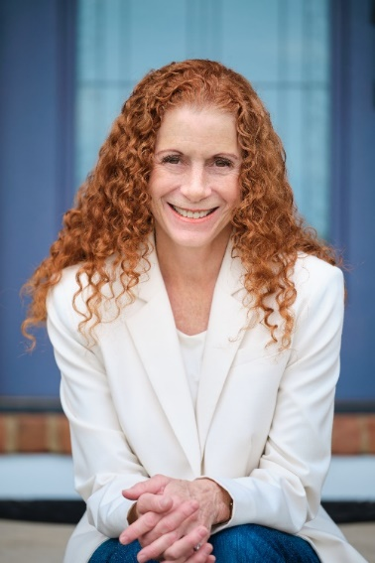nizations in gapore, Malaysia, Thailand, Taiwan, Korea and the Philippines.
​ad responsibility for the Caribbean and Latin American regions during his corporate tenure.

