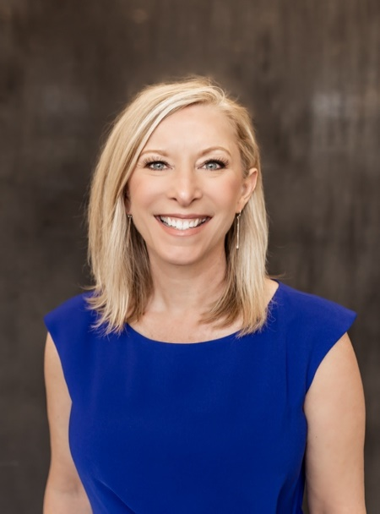**Michelle Hubert** is a principal consultant at Korsgaden Insights, where she partners with leaders in the insurance and financial services industry to drive operational excellence, scalable growth, and client-focused cultures.

A leadership coach, dynamic speaker, and author of *Living with Purpose*, Michelle is known for translating complex business challenges into actionable strategies that elevate performance and ignite lasting success. Her mission is to empower leaders to align their purpose with high-performance systems—and build organizations where people and results thrive.

With more than three decades of experience in field leadership and agency development, Michelle has a proven track record of driving impact. She has served as a team member, an agent, manager, director, and regional vice president, leading teams of hundreds and has guided thousands through meaningful transformation.

Before joining Korsgaden Insights, Michelle served as Regional Vice President, where she led eight agency managers and a cross-functional team supporting over 300 agents and 500 team members. A Million Dollar Round Table qualifier, she has built and scaled high-performing teams from the ground up.

Michelle has served on the board of directors for Finseca and has held leadership positions with GAMA International and the GAMA Foundation. She is an IASSC Certified Lean Six Sigma Green Belt™, a certified trainer for the John Maxwell Team, and a champion for purpose-driven leadership.

She lives in Manhattan, Kansas, with her husband, Tim, and enjoys time with her sons Braydon and Cayle, daughter-in-law Krista, and their children, Brylee and Kayson.

Connect with Michelle at **michelle@korsgaden.com**  
Learn more at [**korsgaden.com**](https://www.korsgaden.com/)

